Bezier Curves and Surfaces

Reference book ‘Mathematical Elements in Computer Graphics’ by Rogers and Adams.
Free form surface machining : a brief overview

A free form surface or shape can be generated in a variety of ways. It can be machined out of a solid body with a cutter, it could be bent into shape from a sheet metal with impressioned dies. EDM or ECM with conjugate shaped electrodes could also be employed. Last and probably the most promising and versatile method, rapid prototyping, can be used to generate free form surfaces. In case of impression die forging, EDM and ECM, a free form surface would have to physically pre-exist, from which the required shape would be derived. In other words, some kind of part-specific tooling would be required. In case of EDM, the electrode- is the part-specific tool for producing a definite free form shape. These electrodes, in turn, are made by CNC machining of graphite or copper. CNC does not require part-specific tooling.

So, instead of CNC machining a 3-D profile out of a block of material, we CNC machine the conjugate shape out of copper or graphite. This is then used as an electrode in EDM to get the shape of the die. These dies are employed as dies impression die forging to get the job.

We do this as CNC milling of the hard die material would have cost us a lot. Machining of hard materials would require more tools or more frequent tool sharpening. Instead – EDM or ECM, which have nothing to do with hardness, would do quite well.

In free form surface machining, a ball end milling cutter needs to be employed, if a 3-axis CNC machine is used (Question – this means, in case you are interested to machine a free form surface on a 3-axis machining center, you cannot use the standard flat-ended miller cutter but have to use the ball ended milling cutter – why?). However, flat end milling cutter can also be employed and it can prove to be better than ball end milling. But, in that case, a 5-axis machine is required.
Fig 1 FFSM with ball ended milling cutter

Fig

A ball nose milling cutter enables a near-point contact between the cutter and the work piece surface. This eliminates to a great extent, an undesirable phenomenon called gouging.

The basic idea of free form surface machining with a ball nose cutter is to traverse the whole surface in to-and-fro (zig-zag) or spiral paths.

How does the cutter touch the surface and how is the position of the cutter determined ? let us have a look

Ball nose cutter
Ball nose cutter
Ball nose cutter
CC
CC
CC
CL
CL
CL

The points at which the cutter touches a free form surface are called Cutter contact points or CC points. These points cannot define the position of the cutter as they are not defining a fixed point on the cutter. A fixed point could be the center of the spherical portion of the cutter. From the CC point – if we climb along the common normal to the touching surfaces, we would reach the center of the ball nose of the cutter. In this case – the center of the cutter is referred to as a cutter location point or a CL point.

For a Bezier surface – how do we get the common normal and all that ? We simply take the cross product of any two tangents at the CC point (and the two tangents that can be easily found out are the tangents in the u and v directions) – get the normal vector, get the unit normal vector and multiply it by the radius of the cutter and thus get the CL point. ***

There are some specific problems encountered during the calculation of cutter paths in free form surface machining, These are listed as below :

1. Forward step determination
2. Side step determination
3. Gouging
a. External
b. Internal
c. Side

Forward step calculation: We may be drawing nice smooth lines as cutter paths on curved surfaces – but the hard truth is that we cannot make the cutter move along continuous smooth curves. As it is a digital system, the tool velocity can only be changed at regular time intervals. Thus the smooth curves are actually broken down into small straight line segments. These small segments are called forward steps. They are shown as blue arrows in the first drawing.

So if you cannot avoid a path made of straight segments or forward steps - there has to be a proper criterion for the choice of the length of forward step (i.e., the distance between the discrete points along the cutter path). This criterion is based on the deviation of the cutter path from the actual surface. The maximum deviation is made equal to the tolerance on surface form ( e in fig. 2).
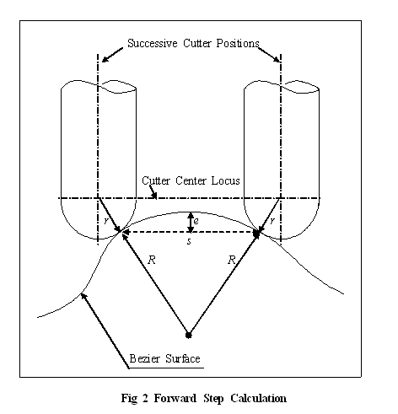

The forward step is determined (except in some special cases) in an iterative manner.
There are various ways of determining the forward step. These will be discussed in more detail after this brief overview of free form surface machining.
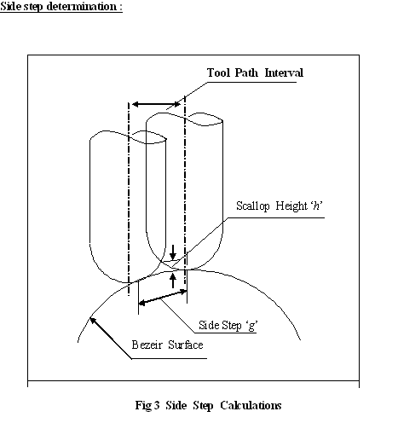

Once a cutter has completed a cut from one edge of the surface to another, it shifts by a specific distance to one side and starts a fresh cut. This is side shift or side step. Side shift has to be provided so that the cutter can start a fresh cut on the uncut portion of the work surface. These are shown as orange arrows.
Now, just as in case of forward step determination, there has to be a criterion for the proper choice of the side step. The main effect of the side step on the work piece surface quality is the resulting roughness. If too large a side step is chosen, high roughness of the work piece surface would be obtained. If too low a side step is chosen, it yields a very high surface finish, but consequently requires a higher machining time. Hence, the choice of the side step should be such that the roughness of the surface at any point is always equal to (ideally) or less than the recommended surface roughness.

There are various strategies for the choice of the side shift. They will be discussed in the appropriate section.

Gouging : Gouging basically means undesirable or unintentional interference of the cutter with the work piece surface resulting in unplanned removal of material. Gouging spoils the work piece surface or part. Gouging can occur in different ways. External gouging occurs when the cutter radius compensation is not properly provided. This is however, a simple fault and has a simple remedy.

When the cutter is machining a free form surface, it cuts the surface in a series of small straight paths. When the cutter is moving along a straight path and has to change direction to cut another straight path at an angle to the first one, it might be stopped on the path and then steered to move along the second. There are different ways of doing it. The cutter might be stopped with its center lying on the normal to the surface at the last point of the path. After that, it might be moved along the second path. However, as obvious from the figure, this will result in the unintentional machining of a portion of the work piece itself. The lower portion of the cutter undercuts the surface. This is called external gouging. External gouging can be avoided by moving the cutter along the straight path until it touches the second path (i.e., both the paths are tangent to the cutter sphere) and then moving along the second straight segment for machining it.

4 External Gouging
Cutter
Work piece
Gouging

Fig 5 Internal Gouging
Work piece
Cutter
If however, a case arises when such tangency conditions do not exist, special remedial measures have to be resorted to.

Internal gouging generally occurs due to an improper choice of cutter diameter while machining internal pockets.

As is clear from the figure, the radius of the cutter is much larger than the radius of curvature of the surface in the narrow pocket shown. In this case, if this cutter is employed to machine this hole, it would interfere with the walls of the hole, thus undesirably machining it. This is called internal gouging. Internal gouging can be avoided by an appropriate choice of cutter diameter for a particular application.

Side gouging occurs when the cutter, while moving along a line on a free form surface, interferes with the surface on the sides. This results in undesirable machining. Side gouging is difficult to avoid and requires considerable computational effort for its detection and elimination.

Different strategies of cutter path generation

There are different strategies of cutter path generation in free form surface machining. These strategies have their own relative advantages and disadvantages.
Some of the methods are :

- Isoparametric method
- Isoplanar method
- Isoscallop method

In the isoparametric method, just as the name suggests, the cutter is made to move along isoparametric lines as cutter paths. The main advantage of this method is that the determination of the cutter paths is not computationally intensive. For determining the cutter paths, we only need to determine points on isoparametric lines on a free form surface. This is simple, non-iterative and straightforward. Isoparametric method, that way, serves its purpose quite satisfactorily for surfaces where these lines are more or less parallel.

However, in case of surfaces which deviate from the typical rectangular shape

Isoparametric lines

Broad end

Fig 7 – Clustering and diverging of isoparametric lines in ff surfaces

As shown in fig 7, the isoparametric liones are bunched up or clustered at one end and tend to diverge at the other. If the cutter is made to follow these lines for machining out the job, it results in drastic variation of surface roughness from one side of the surface to the other.

Surface roughness, as can be seen from the figure, is unacceptably high at the broad end of the work piece while it is low at the narrow end. If a number of cutter paths are generated to obtain acceptable surface roughness at the broad end as well, it would result in redundant machining at the narrow end and subsequently higher machining time.

Side step in isoparametric machining method was determined by a shift along isoparametric lines orthogonal (in the parametric u-v space) to the one serving as the present cutter path. Side shifts are calculated at different points on a cutter path along orthogonal (in parametric plane) isoparametric lines and the next isoparametric lines is chosen as the next cutter path on the basis of least side shift. However, orthogonality in parametric space does not necessarily imply orthogonality in physical space. Hence the side shift, which has to necessarily be orthogonal to the cutter path, might not be so in the physical space and is thus not perfectly correct. However, sidestep can always be calculated by any other method, to be discussed later in connection with other strategies.

Isoparametric method finds wide applications simply because it is one of the very first of its kind to be developed, implemented and commercialized. Further, for aesthetic applications, where surface roughness is not a limiting criteria, or where a secondary surface finishing process is possible, isoparametric method of machining is just as good a strategy as the others.

Forward step in isoparametric machining :

The method described under isoscallop machining with co-planar assumption can be followed here (see below).

Isoplanar machining :

Isoplanar machining is another strategy of cutter path generation in free form surface machining. In this method, the cutter paths are obtained by the intersection lines between a free form surface and a number of parallel vertical planes. As the planes are parallel, successive cutter paths are equispaced when viewed along the direction of the planes. However, this does not necessarily mean that the roughness (=scallop height) is also the same throughout the lengths of the cuts. This is because roughness depends not only on the radius of the cutter but also on side step and the radius of curvature of the surface in a plane normal to the direction of the cutter velocity vector (tangent to cutter path) at that point. So, of the three (that is, cutter radius, side step and surface curvature), the first two are made constant in case of isoplanar machining. This ensures that for irregularly shaped surfaces, machining can be completed by a reasonable (i.e., not so many as in isoparametric machining) number of cutter paths. Still, the problem is – roughness won’t be the same everywhere.

Parallel
Vertical
Planes

u

v Bezier
Surface

Cutter Paths

Fig 8 Isoplanar Method : The Surface-plane intersection lines

In comparison, for this category of surfaces, isoparametric machining would require very high number of cutter paths to complete the machining. This is the main advantage of isoplanar method over isoparametric method.

The side step in isoplanar machining method is decided on worst case consideration (like in isoparametric). At different points along the cutter path, side steps are calculated for acceptable surface roughness. That step, which is the minimum among these, is selected. Hence, as mentioned before, the surface roughness is not uniform but everywhere lower than or equal to the allowable roughness.

For determining the cutter paths by isoplanar method, intersection curves between free form surface and planes need to be determined. No straightforward algebraic solution by direct substitution is possible as the planes are defined in cartesian variables and the freeform surface in parametric variables. An iterative numerical procedure is employed for determining these intersection curves. This makes the procedure computationally intensive. In order to determine the surface-plane intersection curve, first, the intersection point between the plane and one edge (boundary curve) of the surface is found out. This is done by a curve-plane intersection algorithm. Once the intersection point is found out, the intersection curve is determined point by point by a marching process. This is called the surface-plane intersection algorithm.

The curve plane intersection algo given below is beyond the scope of RCCM but are included in this text for interested students.

The curve-plane intersection algorithm

The intersection between a curve and an implicit plane (π) is given by the following equation
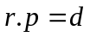 with 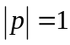
Where, 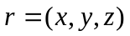 : coordinates variables,
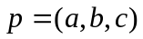: Unit normal vector of the plane (π) and 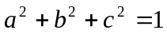.
Then the intersection with the isoparametric curve is given by
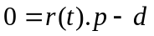
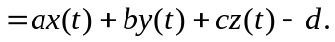
For general parametric curve 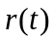, an intersection point if it exists can be obtained by using a Newton-Raphson iteration scheme starting from an initial guess point . Assuming linearity of the curve between the initial guess point and a estimated intersection point :

|| . ( - )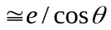
Where, 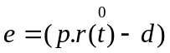,
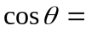(.) / ||.
From the above relation, the estimated intersection point t
is obtained as = - {(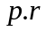() – )} / (.)
Where, =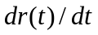 ⎢_{at ,}
a,b,c: Cofficients of plane equation.
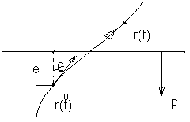
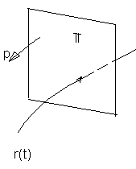

Fig 9 Curve/plane intersection

Intersection between a surface and a plane (This is very much in the syllabus)

The intersection curve between the a isoparametric surface 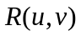 and the plane (π)
Two cases may arise in intersecting the parametric surface with the plane (π). The resulting intersection may be either an open curve or a closed curve. In either case, the overall procedure for solving above equation consists of three steps:
- detection of initial guess points,
- marching , and
- refinement.

The initial intersection points are obtained by finding intersection points between patch boundary curves and the plane. For this, the CPI (curve/plane intersection) procedure may be employed. Having determined initial points, the next step is to define a marching vector. The unit marching vector is taken to be a vector perpendicular to both the surface normal and plane normal. What is this c basically ? It is nothing but the instantaneous direction of the cutter at a particular point, while it (the cutter) is moving along the line of intersection of the vertical plane and the surface.
Namely,
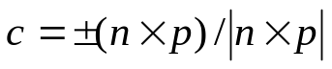 the blue arrow
Where, 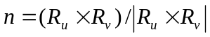 (orange arrow) is the unit normal to surface and is the unit normal (the green arrow) to plane (π).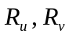are the partials of the surface wrt u and v. 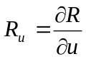 etc.
p
c
n
R(u,v)
dR

The next step is to determine a guess point for the next intersection along the intersection curve. The increments 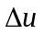 and 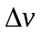of the domain values are determined by solving the following linear equations: (they are basically dot products of a small vector dR on surface with p and c respectively.
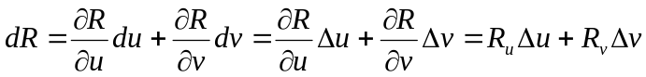 the red arrow

Look at the following two equations – they simply say that the forward step (red arrow) is perpendicular to the plane normal and is in the direction of the tangent to the surface at that point (that tangent which is contained by the vertical plane) and is of segment length δ

In other words dR.c = δ and dR.p = 0
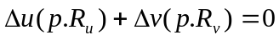 (1)
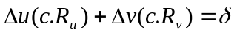 (2)
Where, : 3D stepping distance ,
: Marching vector,
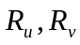: Partials of the surface .
Let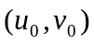denote the current intersection point, then the guess point for the next intersection point is given by
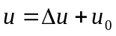 and 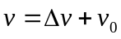
This blue part again is not in syllabus but for interest only
Finally the estimated intersection point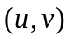 is refined to obtain a true intersection point 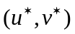. For this, one of the isoparametric curves which is more parallel to is selected and then the CPI is applied along that isoparametric curve to get exact intersection point. For this the following condition is tested:
If 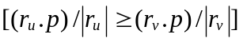 then
Perform CPI between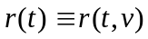 and plane (π) to obtain 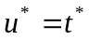and 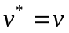
Else perform CPI between 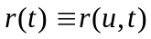 and plane (π) to obtain 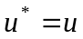 and 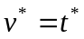

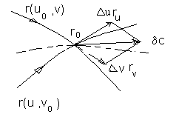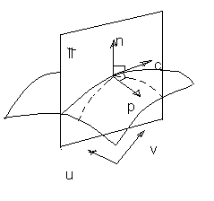

Fig 10 Surface/plane intersection

Now, the aspects of forward step, side step etc will be dealt with w.r.t specific strategies of cutter path generation.

Forward step determination

Circular arc approximation

In almost all cases – the forward step is determined by circular arc approximation. However – there can be other techniques that can yield more accurate results.

In case of isoplanar method – the forward steps taken by the cutter along one particular path are essentially in a single vertical plane. Hence – the forward step calculations would be two dimensional in nature. In fig. 11, two successive positions of the cutter are shown on a cutter path. The plane of intersection is π. The blue vectors are the projections (onto π) of the normals to the free form surface at the two cutter contact points (finding out normals to the free form surface is not new to you – it is there marked as *** above in this notes). The blue vectors are projected backwards to cut each other – so that we can approximate the radius of curvature of the surface to be (R₁+R₂)/2 in π. Hence – we can equate

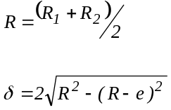 eqns (3) & (4)

Where e is the tolerance on the surface form accuracy. δ is the forward step on the surface. This forward step is used in eqn (2). The procedure would be

π
Successive Cutter Positions

Cutter Center Locus

r e r
δ
P(u1,v1)
P(u2,v2)
R₁ R₂
θ

Bezier Surface

Fig 11 Forward Step Calculation

- Apply the CPI algo to get a point P(u, v)on the edge of a surface P(u, v). This is the start point of a cutter path. This is the intersection point of the edge of the surface and the vertical plane that you have started with.
- Define a guess value of δ to go to next point on the intersection curve. Generally this guess equals final δ of last forward step. If reach surface edge – stop please and get ready for the side step.
- Apply SPI algo to get the next point on the surface on the cutter path – that is, get delta u and delta v and thus, u2=u1+delta u, v2 = ….
- Refine by CPI
- Once you get u1,v1 and u2,v2 – you can find the normals at the two points. Producing them backwards – get the radii at the two points. Get their mean.
- With the values of e (say 50 microns) and radius R find value of δ (from equations (3) and (4)). If the guess value of δ matches this value –select δ as path length. Go to 3. Else
- Run SPI again with changed value of δ (that is – go to 2)
- Refine results by CPI
- Go to step 5

Once the full cutter path (edge-to-edge) has been determined, a side step has to be taken. For this, the side steps are calculated at each and every cutter contact point (for tolerable surface roughness) on the cutter path (just completed) and the minimum one is adopted. This ensures that the roughness created by the side step is nowhere more than the tolerable limit.
Side steps in case of isoplanar method can be found out by methods similar to analysis by Suresh and Yang [1] and is not elaborated here.

Isoscallop machining

Once the idea of forward step and side step determination is understood from the previous two strategies, isoscallop method is not difficult to understand. First – the basic idea is to calculate the side step at each point in a cutter path such that the scallops are uniform in height. Uniform surface roughness is the requirement in many engineering applications like aerofoil surfaces, die faces etc.

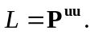n 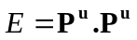
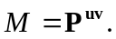n 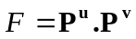 … (1)
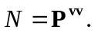n 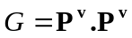

k = local curvature along cutter path p(t) = normal curvature k_{n}

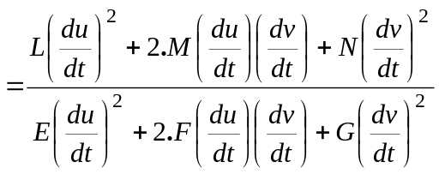 ….(2)

I 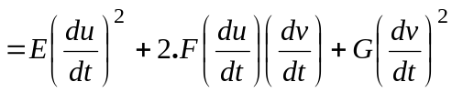 … (3)

But we still need to have a look at how forward step is decided before we move onto side step determination. So we are now into isoscallop – but first the forward step part of it.

Forward step Calculation

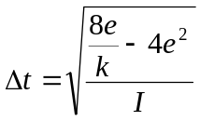 (13)

e = specified tolerance

Now what is k or k_{n} ?? It is the normal curvature and equal to 1/R. Normal curvature of a surface in a particular direction is the curvature of a curve on a surface at a point formed by the intersection of a plane with the surface. This plane is defined by the normal to the surface at that point and by the tangent to the surface at that point in the direction along which the curvature is to be determined.

For free form surface, the normal curvature is given by

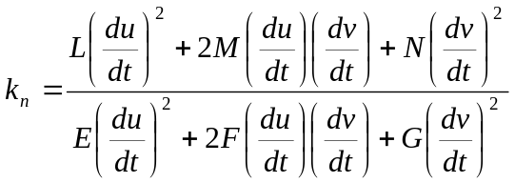

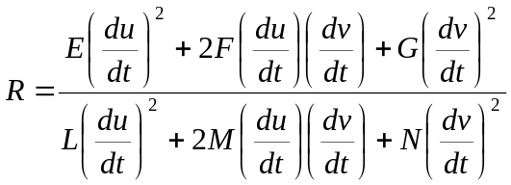

Dividing the numerator and denominator by (du/dt)² ,the above expression reduces to

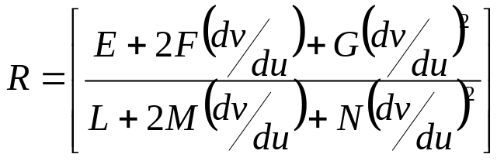

Hence – if you put a particular dv/du, you would get the Radius of curvature in that direction (dv/du defines a direction on the surface). So – during the forward steps – you would use dv/du pertaining to the cutter path tangent and during side steps – you would use the dv/du pertaining to the side step tangent. You would learn more about the side step tangent later.

Forward steps can be calculated this way :

With circular approximation (discussed previously under forward steps for isoplanar machining), the forward step can be considered as

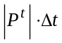 where P^{t} is a tangent (the orange arrow) to the cutter path curve (blue) expressed parametrically in terms of a parameter t. The cutter path curve lies on P(u,v) and is expressed in terms of a parameter t.

P(u,v)
P^{t}
P(t)

P(t)

Here the orange line is the tangent, the green line is the forward step and is so very close to the tangent that its length dP can be approximated by

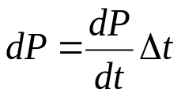

Which means when we hop along the curve (which is P(t)) we are essentially moving from P(t) to P(t+Δt)).
dP/2 is one side of a right triangle where the other two sides are the black line (=R-e) and the red line (=R)

also

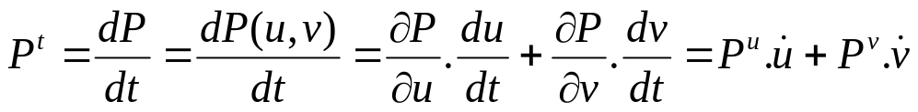

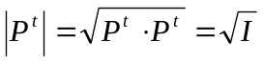 (I am sure you can prove this. See equation 3. I is called the first fundamental form of a surface)

Now, if you simply apply Pythagoras theorem to the circular approximation – and put k = 1/R – you would get the answer (that is – the equation 13)

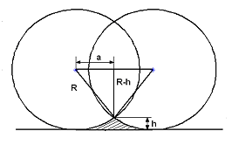

Fig. 12 – side step for flat surface

Side step Calculation

The side step has to be found and it has a magnitude and direction. The direction should be along the surface and at right angles to the cutter path. So, if cutter path direction is designated by a tangent at a particular point, the side step direction would be given by another tangent to the surface at that point normal to this tangent.

General equation of a tangent P(t) on a surface surface P(u,v) is

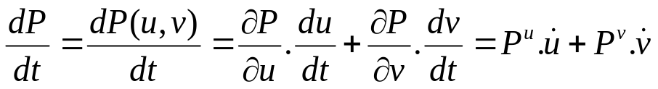

Orthogonality / normality of two such tangents

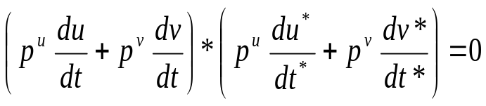

And you can show from here that

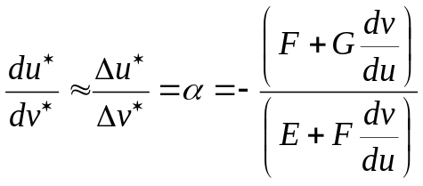

- This helps you calculate the radius of curvature

The above equation is the dot product of two tangents – one in the direction of the cutter path and the other orthogonal to it (with the asterisk mark). The idea is – the cutter side step should be orthogonal to the cutter forward step (So dot product), while the direction of both should be on the surface (so both are tangents).

Ok so the previous equation gives you some info on the direction of the side step. What about the magnitude of the side step ?? Lets us have a look at the difference between the two adjacent cutter contact points P* and P defining the side step.

modulus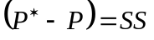 = side step

The above equation states that while the direction of the side step is stated in the previous eqn, the magnitude is given by the side step, the figure 12 showing side step for flat surface.

We can also state that

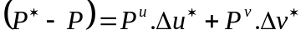

The following equations relate the side steps with center distance for flat, convex and concave surface respectively

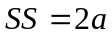

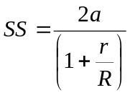
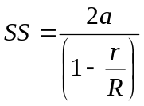

Now how do you get the radius of curvature R of the surface ? Go back and you will find it discussed under forward step

The following equation gives half the side step = half the center distance for flat surface
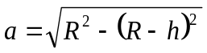

Side step is a function of the roughness height (h)(the allowable value is adopted ), the radii of the cutter ( r ) and that of the surface ( R* ) in the orthogonal direction. Thus, side step is calculated as follows.

Cutter end

A D B
Free Form X
Surface L P M

Radius of curvature 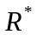
Fig 5.5(b) Case 2: A Convex Surface

Cutter end

A D B

Free Form X
Surface L P M

Fig 5.5(c) Case 3 A Concave Surface

In fig. 5.5a, b and c,
AB=distance between centers=2a
PX=scallop height=h
LM=side step=g

R*=Radius of curvature along LM

Considering three different cases,(Students this algebraic manipulation is not in syllabus – just for your interest) →

Case1: Zero curvature: (fig 5.6a)

DX=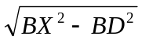=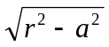 (5.8a)

h=DP-DX= r-
a=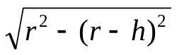
g=2a

case2: Convex curvature: (fig.5.5b) O is center of curvature of surface
OD=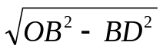 = 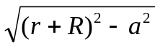
DX= = 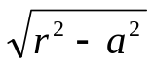
OX=R*+h=OD-DX (5.8b)
h=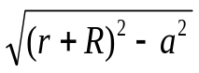 - -R*

a = 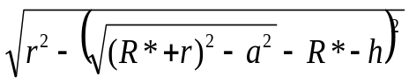
g = 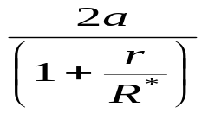

case3: concave curvature ( fig.5.5c )

OD = 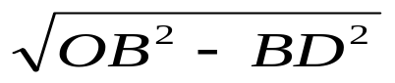 = 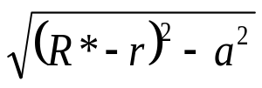

DX = 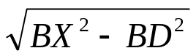 = 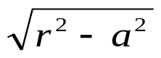

OX = (R* - h) (5.8c)

h = R* - 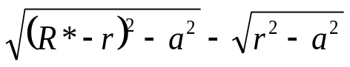

a = 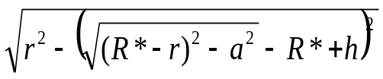

g = 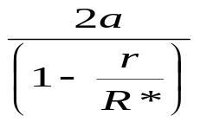

The equations 5.8b and 5.8c are iterative equations, with the initial value of “a” determined from equation 5.8a.

Ignore all the maths above and understand that we can find out the side step by determining its direction to be orthogonal to the cutter direction and the magnitude to be such so as to produce a scallop height of acceptable roughness)
Now, the side step magnitude is known together with the direction in which it has to be taken. The following equations are used to find out the exact position of the parallel point ( A parallel point is the position of the cutter on the adjacent cutter path with respect to a CC point on the primary tool path so that the stipulated roughness is produced in between the two paths at that point ).
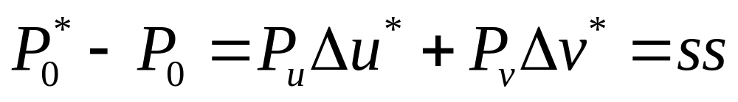

So you have two unknowns Δu* and Δv* and you simply solve them.

Ultimately – we get the two u and v increments as

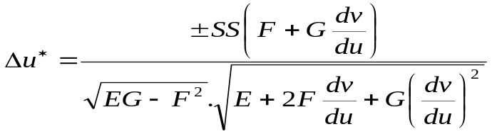

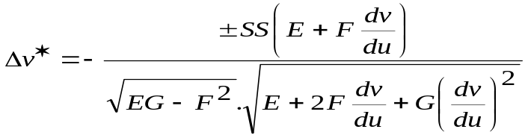

once the side step is known – all the points through which the cutter path passes can be determined for the second path. This process is repeated till the whole surface is covered. Mind you, the points which are found on a secondary cutter path are first collected and a smooth curve (in the u-v 2D plane) is passed through them. Next – the curve is extended or truncated upto the edges of the surface and points are chosen on this u-v curve in such a way that in the x-y-z space – these points would give acceptable forward steps for the cutter.). In the figure – circular dots are points obtained by side step calculation – they are smooth curved and square dots are the forward step approximated points.

v

u

FREE FORM SURFACE MACHINING

Isoscallop machining as per Feng and Li method

STUDENTS – THIS IS ALSO NOT IN SYLLABUS – BUT FOR YOUR INTEREST

Feng and Li stated that the 2-D geometrical calculations for the magnitude of the side step in suresh and Yang’s formulation was an oversimplification. They said that the groove cut by the tool was due to the tool sweeping through material. These ‘sweeping sections’ or ‘swept sections’ of the cutter for adjacent positions on two cutter paths were not necessarily co-planar. Suresh and Yang assumed just that. Errors were seen to accumulate over cutter paths and result in sizable errors in their case.

Developing Secondary Cutter Paths by the Feng and Li method

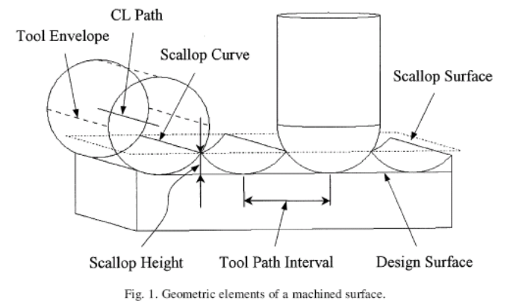
Determination of cutter paths for Isoscallop machining involves two steps. First, the existing cutter path is used along with the scallop height specification to generate the adjacent scallop curve on the surface. Once the scallop curve has been obtained, it is used to generate the adjacent cutter curve. This is known as the sidestep calculation.
The next step aims to determine the points on the surface through which the cutter will actually pass to machine it, by using the tolerance limit specification. This is known as the forward step calculation.

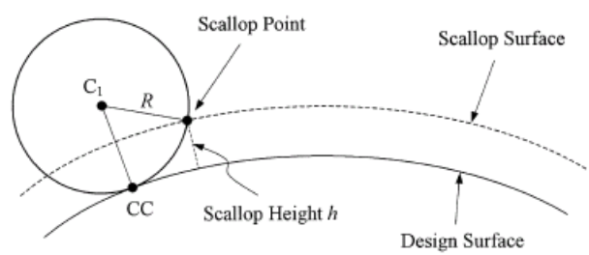

See the first figure and notice the scallop curve. It is simply the intersection between the adjacent swept tubes (envelopes of the swept sections) of the tool. The intersection between two adjacent swept sections is the scallop point.

The scallop surface means a surface which is away from the actual surface by the scallop height h.
To find out the scallop curve, the intersection between scallop surface and the tool envelope of the cutter path is calculated. The scallop surface P_{sc}(u,v) is defined as:

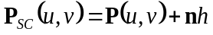

where P(u,v) is the parametric surface, n is the unit surface normal and h is the scallop height specification.

The solution of the scallop points is done by a Newton-Raphson technique. It is to be noted that the scallop points are found out for every cutter position and these scallop points are now joined by a parametric curve so that the tangent to this scallop curve at any point can be determined. The scallop curve lies on the swept surface or swept tube of fig above and is shown in bold blue dotted line. The scallop tangent is tangent to the scallop curve and hence should be tangent to the swept tube surface as well (If you are a resident of Punjab – you are a resident of India as well). Hence – it should be perpendicular to the normal to the swept tube at that point which is not other than the radius vector of the corresponding swept section. That’s it and nothing more. Hence – it is not necessarily perpendicular to the concerned swept section plane. This same scallop tangent is also perpendicular to the adjacent cutter radius vector but is not necessarily perpendicular to the adjacent cutter swept section. Hence, the adjacent cutter swept sections are not necessarily co-planar and this is the main observation of the Feng and Li.

Once the scallop curve has been identified, adjacent tool curve can be computed in a similar fashion.
The center of the swept section of the adjacent tool position lies on the circumference of a circle of radius R (cutter radius) and with center as the scallop point and lies on a plane normal to the scallop tangent. Intersection of the tool center surface with this circumference gives the Cutter location point on the adjacent tool path corresponding to that scallop point. Solution of all the CL points gives the cutter location curve of the adjacent tool path. (Tool center surface is similar to scallop surface → it is a surface offset from the actual surface by a normal shift of tool radius.
Sidestep calculation is followed by the forward step calculation. Forward step calculation has been carried out as follows: not discussed in class – not in syllabus →

δ = d²/8ρ_{t}
where ρ_{t} is the radius of curvature of the surface in the feed forward direction, d is the incremental length and δ is the maximum chordal deviation or tolerance limit specification.

Further reading

[1] Suresh, K. and Yang, D.C.W. ‘Constant scallop height machining of free form surfaces.’ Journal of Engineering for Industry, Transactions of ASME, Vol. 17, 1994, pp.253-259
[2] Lin Rong-Shine, Koren Y. ‘Efficient tool path planning for free form surfaces.’ Journal of Engineering for Industry (ASME Trans), 1994.
[3] Sharma, R and Dutta, D., ’The geometry and generation of NC tool paths’, Journal of mechanical Design, Vol. 119, 1997, pp. 253-258
[4] His-Yung Feng and Huiwen Li., ‘Constant scallop height tool path generation for three-axis sculptured surface machining.’ Computer Aided Design 34 (2002) pp 643-654.

Summing up – Isoscallop machining

- Identify CCPs on one edge of surface
- Find out CLPs for those CCPs
- Pass smooth curve through the CLPs to get cutter location curve
- Get the cutter velocity directions as tangents to the cutter location curve
- Obtain cutter swept sections as normal to the cutter velocity directions
- Find the offset surface as = P(u,v) + n.h
- Find intersection between offset surface and swept sections to get scallop points
- Pass smooth curve through the scallop points to get scallop curve
- Obtain the scallop tangents as tangents to the scallop curve
- Scallop tangent is normal to radius of cutter joining center of cutter and scallop point.
- Define plane normal to scallop tangent
- With center as scallop point and radius as cutter radius, draw circle on this plane – the cutter center should lie on this circle
- Find out adjacent cutter center position which is lying on this circumference and is away from the design surface by ‘r’ (cutter radius).
- Process repeats

